Node.RED Setup
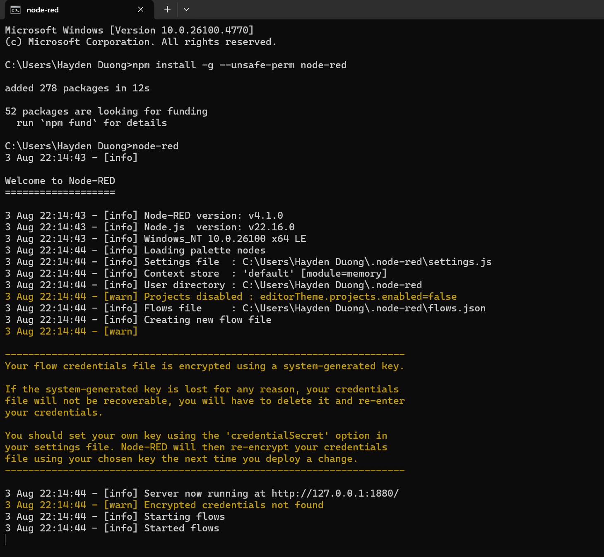 Picture 1 – Node-Red is successfully installed.
A Simple Application
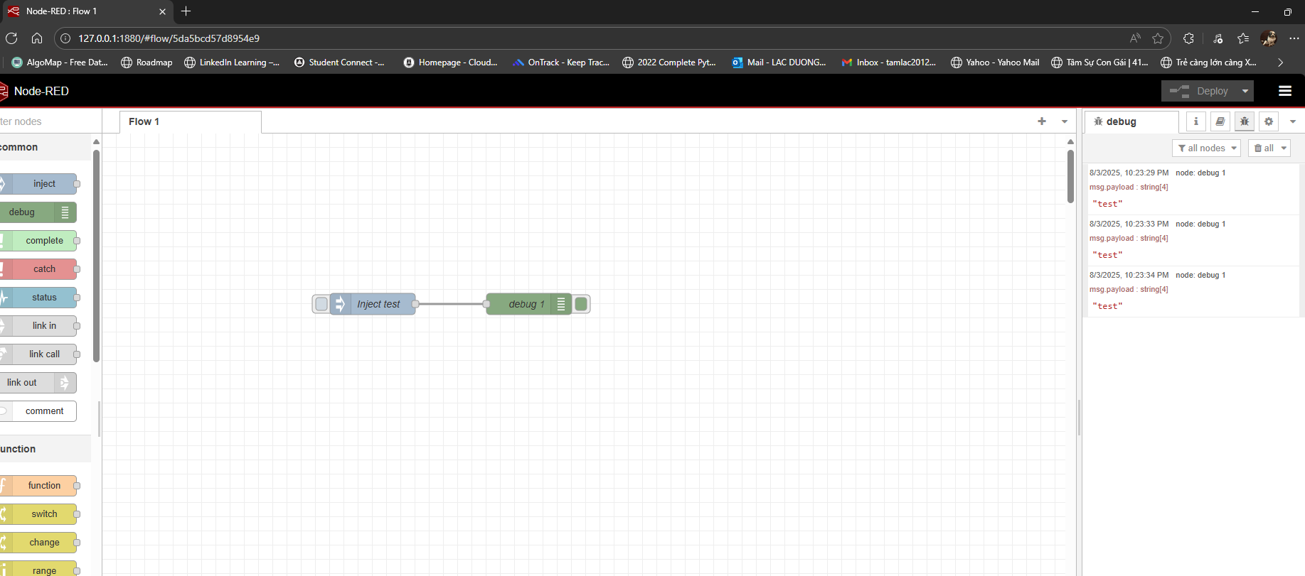
Picture 2 – Successfully sent string “test” as payloads.
Building a Smoke alarm by Combining Node-RED with MQTT
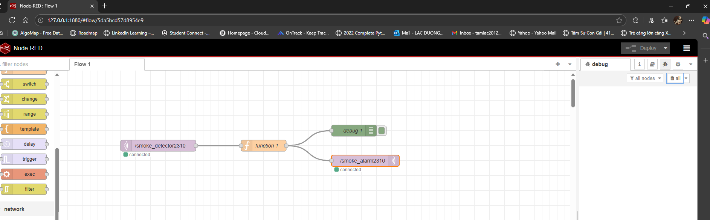
Picture 3 – Successfully deployed the system as instructed.
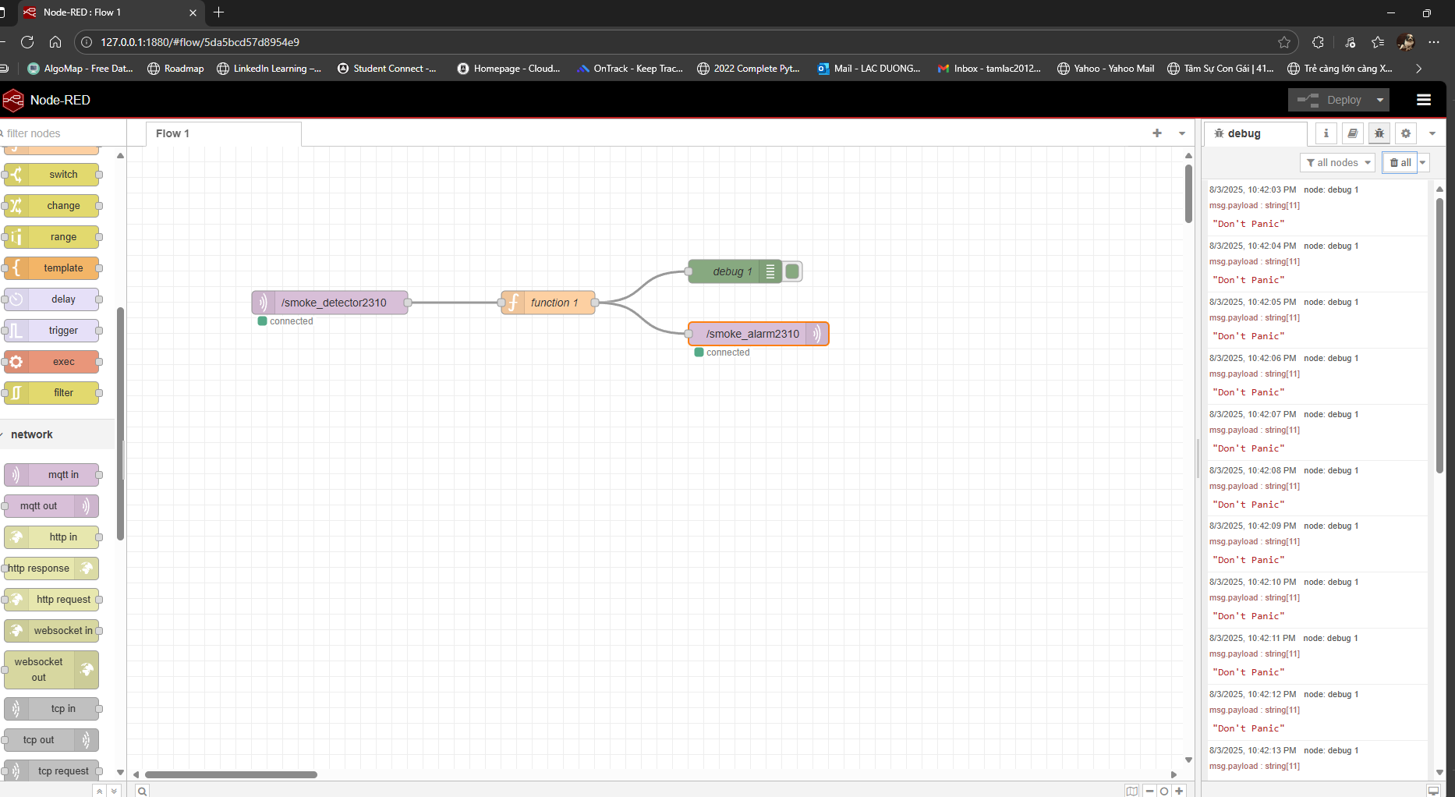
Picture 4 - Successfully display the warning messages.

